**Final Project Plan**

Sefira Karina /2001586155

Basically, the plan for the final project is to create a program to calculate student’s test scores into the final score in the mid/final report card. The steps of the program will go like the following statements bellow :

1. The program perhaps will ask the user to enter the number of students and their names.
2. User will have to input the scores of the students on their first exam.
3. The program will determined if there will be a re test or not
4. If there’s a retest, go back to step 2
5. If there’s no retest , show the name of the student that will have to go through remedy and asked the user to input their remedy scores.
6. After step 4 or 5, the user will probably be shown all the students final scores for the 1st test. (if retest replace the scores with the new one , the max scores will be 100) ( if remedy ,replace the scores with the new one , the max scores will be the minimum passing score .
7. After done with the first exam ,the program will asked for the 2nd exam score and process it the same way with the 1st exam.
8. Then , the final scores for the exams will be calculate into the scores for the report card
9. After that , the program will ask user to input the mid test’s scores . But , for mid test , there’s no remedy m only mid test
10. The program will calculate the final scores for the report , that being 70% of the average test score and 30% of the mid term .
11. The user will see the report card scores .

**WEEK 2**

Int Main

Enter the number of students (max 50)

Make array to input student’s name (name[i])

Make array to input student’s score (score[i])

So far , I’ve done these steps , actually , I wanted to do one more step (determined if the student’s score is bellow the minimum score or not and cout the names of the students with red mark) and I’ve tried using :

for (int i=0 ; i<students ; i++)

{

if (score[i]<minScore)

{

name[i]=noPassName[i];

score[i]=noPassScore[i];

}

cout <<noPassName[i]<<endl;

}

This can be compiled,but it didn’t really cout anything in the program. So I decided not to used it and searched for another way but haven’t found the right way yet.

**WEEK 3**

Int Main

Make array to input student’s score (score[i])

Input retest score

If there’re red marks , input it

Enter the number of tests given

Enter the number of students (max 50)

Make array to input student’s name (name[i])

Final score for the test

**Week 4**

This week I managed to put the code into functions so it becomes more organized and so if I want to use that part again , I’ll just have to call the function. So far , I’ve made 3 functions :

1. studentsName()
2. calcScores()
3. testResults()

Actually , this week’s target was to finished the code to calculate each student’s average test score . But I haven’t found the way to do it yet . So,the output now is :

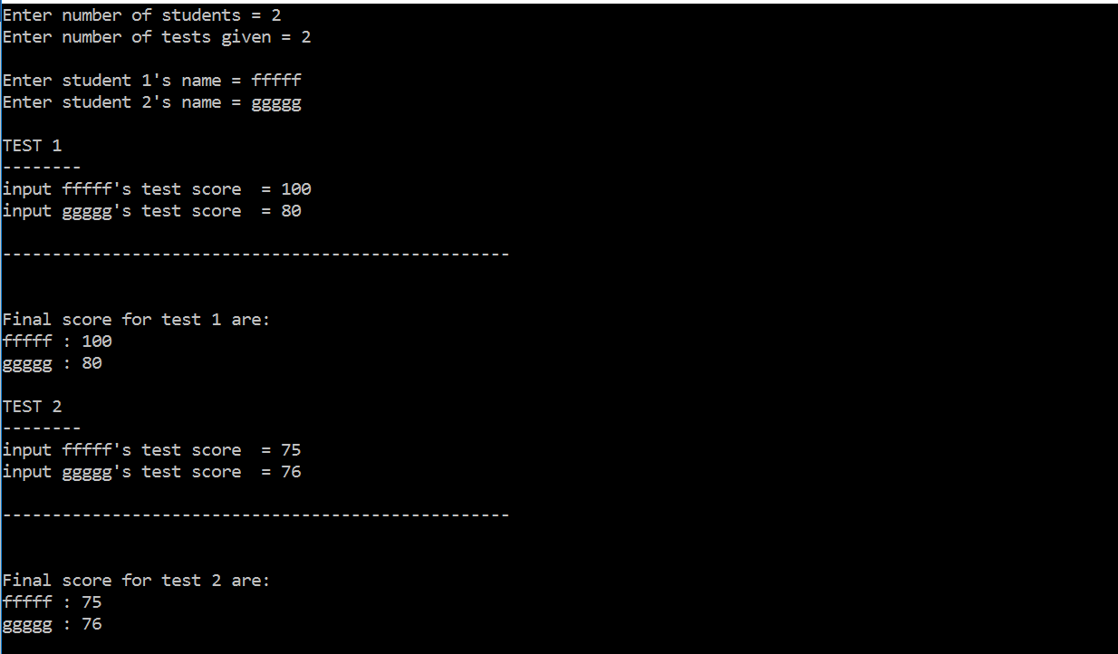

🡪 score[i] (for the 1st test)

🡪 score[i+1]

🡪 score[i](for the 2nd test)

🡪score[i+1]

And I’ve tried several ways , one of them was :

for (int i=0 ; i<students ; i++)

{

cout << name [i] << " : "<< (score[i]+score[i])/tests) <<endl ;

}

But it didn’t work because it just caculated the score of each student from the same test.

**Last week**

This week , a class was added to the program . The private being the amount of students and their names . A function to canculate the 1st and the 2nd tests was added too ,along with the function to input the mid test and to calculate the final score (70% of the average test score and 30% of the mid test).Current output example :

